Motion-Approval of a grant in the amount of $3500 for the CVMCS Sensory Pathway for purchase of new sensory activities and upgrades and maintenance of space. See below for details.

Funds available in their Fund for Today- $15,941.10

Staff recommendation-Approval

CVMCS Sensory Pathway Request for Funding Support

January 30, 2025

Amount Requested
- $3,300 for purchasing sensory activities (puzzles, mazes, activity boards, balancers, etc.) – one time grant
- $200 for maintenance and upgrades to space (floor decal replacement, new sensory items, etc.) – ongoing annual grant

Background
Chippewa Valley Montessori Charter School is requesting funds to support the creation of a sensory pathway in our school. A sensory pathway is a designated area with engaging, movement-based activities that promote emotional regulation, support breaks in cognitive work (brain breaks), and continue the development of children’s neurological and sensory systems.

Sensory Pathway to Serve Students
We want to create a sensory pathway to serve our students in two specific ways:

- Support the development of students’ neurological and sensory systems. Research shows that the maturation of these systems impacts a child's readiness for learning (i.e. regulation of attention, body movement, and emotions, as well as development of fine motor skills and spatial awareness).

Some students begin school under-developed in their learning readiness and sensory pathways are a way to support those students to have extra time to strengthen and hone the skills they need so they can keep up academically with their peers and remain confident in themselves.

- Provide students with engaging activities when they need breaks from the classroom. Some students can get overstimulated in a classroom and need to take a break to reset and regulate their nervous and sensory system. Other students need an engaging and rewarding activity to boost their focus and attention, so they can return to the classroom ready to complete work assignments.

The sensory pathway will provide the environment and support needed to help those students have more positive outcomes in their school day.

Project Budget
Start-up budget: $3,300, phased over two years

On-going maintenance budget: $200 per year

Budget Narrative
We’ve developed a start-up budget of $3,300 to purchase items and prepare the space for the pathway.
We will use approximately $3000 of this budget to purchase interchangeable panels that will rotate in use throughout the school year, maintaining interest among the students. The panels will focus on developing fine motor skills and spatial awareness as well as stimulate the senses. The remaining $300 will be used to continue developing the large motor portion of the sensory path.

We anticipate $200 per year will be needed for the replacement of items (i.e. sensory activities, floor decals) and the purchase of any new items to keep the sensory pathway fresh.

Budget Items
The following items will be purchased to develop our sensory pathway:

- Vinyl number stickers- $16
https://www.amazon.com/White-Vinyl-Consecutive-Number-Stickers/dp/B08516H9L2

- Vinyl wall push-up stickers- $10
Amazon.com: Wall Pushes Slide Feet Sensory Path Floor Decals for Kids - Die-Cut Vinyl Sensory Walk Decals - Daycare & School Hallway Decor - Classroom Floor Stickers - Education Sensory Walking Path Stickers : Office Products

- Vinyl directional stickers- $8
https://www.amazon.com/dp/B0CMC5CJRM/ref=sspa_dk_detail_3?psc=1&pd_rd_i=B0CMC5CJRM&pd_rd_w=4xS48&content-id=amzn1.sym.f2f1cf8f-cab4-44dc-82ba-0ca811fb90cc&pf_rd_p=f2f1cf8f-cab4-44dc-82ba-0ca811fb90cc&pf_rd_r=FRTS3X2PKPA10QR60B27&pd_rd_wg=soiMm&pd_rd_r=94f066c9-18b1-404a-9e2e-8ec726ac613c&s=automotive&sp_csd=d2lkZ2V0TmFtZT1zcF9kZXRhaWxfdGhlbWF0aWM

- Vinyl tiptoe stickers- $18
https://www.amazon.com/Airplane-Die-Cut-Vinyl-Sensory-Decals/dp/B0BYB7JJ3M/ref=sr_1_6?crid=1P4SQQ2R5OLPH&dib=eyJ2IjoiMSJ9.hePgPmOhPCB4uJdA3jP35ZjfqWCzAFnFrcZ1UALRKxFeB9Hra7njgw9ZMVhLGKUe4uGPNm8T9546m04-s7gYcYCe2J_kW57XMx95mDw7U-8SeiiIZdpd_vQyVvnzRgZ1-H2bsm__ZnCnzryrc3fT_RkiBawTbnWTvboRFns27woyX-gLCCR5aWvGQ4jOSbObvbkweDW1ID8NCGgJAWscuhQKcUjrH5lqDW7DYXxU7XLXI-zhST4Dze89U7HTIu3zLQhj_Hw7CyZW5ITe73DxC11vuPdkc0PPYTqk7Vdvdu2IpbnTwZ2I2h30_0kzwSRPo3C1mymajucvyvnqvbOwrVBTbaz4EUDF7cvSJPCSmWs6mcG2d3FL8AwpofRoaO3Gxgkv_MWmDS_v62G8rWJWpUwQ4aWq6C7aMH1Rb9xEho8fqnlzyWQlgJx6HbojQacq.WXs0MJjEODmOM73WhE3MaISFeX4n5dmPUJxN4W_vyKw&dib_tag=se&keywords=Tip+toe+floor+sticker&qid=1738179141&sprefix=tip+toe+floor+sticker%2Caps%2C121&sr=8-6

- Balance seat- $200
https://www.smirthwaite.co.uk/product/rocking-ball/

- Vinyl footprint stickers- $10
https://www.amazon.com/gp/product/B08DCGYRFW/ref=ewc_pr_img_4?smid=A3862JF7NYRTR9&psc=1

- Hardware, paint, and plywood- <$100

- Sensory wall panels from Playscapes- $3000 (see attached list)


Shopping Cart

Total
Subtotal | $2,998.00
Shipping (Shipping & Handling - Calculated at Checkout.) | $0.00
Order Total | $2,998.00

Item | Price | Qty | Subtotal
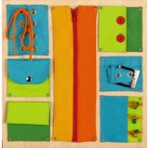  HABA Pro Closures Sensory Wall Activity Panel, 1120370001 | $171.00 | Qty | $171.00
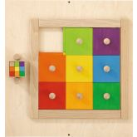  HABA Pro Colorful Squares Sensory Wall Activity, 1023145001 | $544.00 | Qty | $544.00
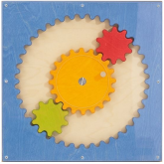  HABA Pro Acrylic Gears Sensory Wall Activity Panel, 1120394001 | $405.00 | Qty | $405.00
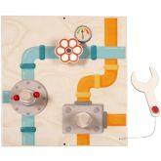  HABA Pro Mechanic Sensory Wall Activity Panel, 1156921001 | $239.00 | Qty | $239.00
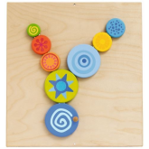  HABA Pro Special Effects Turning Discs Sensory Wall Activity Panel, 1120390001 | $262.00 | Qty | $262.00
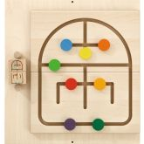  HABA Pro Labyrinth Sensory Wall Activity Panel, 1023139001 | $243.00 | Qty | $243.00
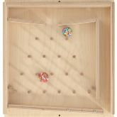  HABA Pro Plinko Rubber Ball Wall Activity Panel, 1023138001 | $353.00 | Qty | $353.00
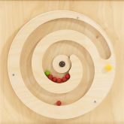  HABA Pro Turning Spiral with Balls Sensory Wall Activity Panel, 1120396001 | $334.00 | Qty | $334.00
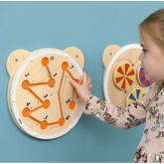  Maze Sensory Wall Activity by Moje Bambino, MB542113 | $59.00 | Qty | $59.00
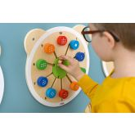  Match the Numbers Sensory Wall Activity by Moje Bambino, MB542111 | $53.00 | Qty | $53.00
 | $53.00 | Qty | $53.00
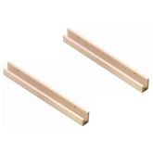
HABA Pro Set of Upper and Lower Sensory Wall Panel Guide Rails, 1120189001
Select Guide Rail Length
2 x 1120190001 - 32"L For Two Sensory Wall Panels +$82.00
 | $141.00 | Qty | $282.00

